CHAPTER 1
INTRODUCTION
1.1 Overview
In the modern era, the integration of technology into everyday life has significantly influenced the way individuals approach health and fitness. With the rapid growth of digital platforms and artificial intelligence, the fitness industry has experienced a transformation from traditional workout methods to smart, data-driven solutions. The increasing demand for personalized fitness experiences has led to the development of intelligent systems that can adapt to individual user needs and provide real-time guidance.
The project titled “AI-Based Fitness Tracker & Gym Management System (Web Application)” is designed to address this growing demand by combining fitness tracking capabilities with gym management functionalities in a single unified platform. This system leverages the power of Artificial Intelligence to enhance user experience, improve efficiency, and provide personalized fitness recommendations.
The application is developed as a full-stack web-based system, ensuring accessibility across various devices such as desktops, laptops, tablets, and smartphones. The frontend is built using HTML, CSS, and JavaScript, focusing on a modern dark-themed user interface with smooth animations and interactive elements. This ensures that users have an engaging and visually appealing experience while navigating the application.
The backend is developed using Python Flask, which serves as a lightweight yet powerful framework for handling server-side logic, processing user requests, and managing communication between different components of the system. The database used is MongoDB, a NoSQL database that provides flexibility in storing and managing dynamic data such as user information, workout details, and progress records.
One of the most significant aspects of this system is the integration of Artificial Intelligence using Ollama. The AI component plays a crucial role in enhancing system functionality by providing intelligent workout suggestions, chatbot assistance, and analytical insights for administrators. This enables the system to move beyond static functionality and deliver a dynamic, adaptive user experience.
In addition to AI features, the system also integrates the Nutritionix API, which allows users to access detailed nutritional information about their diet. This feature supports users in maintaining a balanced lifestyle by combining workout tracking with dietary analysis.
The system is designed to serve two primary categories of users: general users and administrators. General users can register, log in, select workouts, track their progress, and receive AI-based recommendations. Administrators, on the other hand, have access to a dedicated dashboard that allows them to manage users, monitor system activity, and analyze performance metrics.
Overall, this project aims to create a comprehensive and intelligent platform that bridges the gap between traditional fitness tracking and modern AI-driven solutions. By integrating multiple functionalities into a single system, it provides a holistic approach to fitness management and gym operations.
1.2 Problem Statement
Despite the availability of numerous fitness applications and gym management systems, there are still several limitations that hinder their effectiveness and usability. Most existing systems are designed with a limited scope, focusing either on fitness tracking or administrative management, but rarely both. This lack of integration results in inefficiencies and a fragmented user experience.
One of the major challenges faced by users is the absence of personalized workout plans. Traditional fitness applications often provide generic workout routines that do not consider individual factors such as fitness level, goals, or physical condition. This leads to reduced effectiveness and lower user engagement.
Another significant issue is the lack of real-time guidance and intelligent support. Users often require assistance in selecting appropriate workouts, maintaining proper form, and tracking progress. Without interactive features such as AI chatbots or recommendation systems, users may struggle to achieve their fitness goals.
Diet and nutrition tracking is another area where many systems fall short. While some applications provide basic calorie tracking, they often lack detailed nutritional analysis and integration with workout plans. This creates a disconnect between exercise and diet, which are both essential components of a healthy lifestyle.
From the perspective of gym administrators, the challenges are equally significant. Many gyms still rely on manual processes for managing memberships, tracking user activity, and maintaining records. This not only increases the risk of errors but also consumes a considerable amount of time and resources.
Additionally, existing gym management systems often lack analytical capabilities. Administrators have limited access to insights regarding user behavior, system performance, and overall engagement. Without such data, it becomes difficult to make informed decisions and improve services.
Furthermore, security and scalability are common concerns in traditional systems. As the number of users increases, systems may struggle to handle the load efficiently. Similarly, inadequate security measures can lead to data breaches and unauthorized access.
The problem addressed by this project is the development of a comprehensive system that overcomes these limitations by integrating fitness tracking, diet management, and gym administration into a single platform. By incorporating Artificial Intelligence, the system aims to provide personalized recommendations, enhance user interaction, and improve overall efficiency.
1.3 Motivation
The motivation for developing this project stems from the increasing importance of health and fitness in today’s society, combined with the rapid advancement of technology. As individuals become more health-conscious, there is a growing demand for tools that can help them manage their fitness routines effectively and efficiently.
One of the key motivations is to enhance user engagement through personalization. Traditional fitness systems often fail to keep users motivated due to repetitive and generic content. By integrating AI, the system can analyze user data and provide customized recommendations, making workouts more relevant and enjoyable.
Another important motivation is to simplify gym management processes. Gym owners and administrators often face challenges in managing memberships, tracking user activity, and maintaining records. Automating these tasks through a digital platform can significantly reduce workload and improve efficiency.
The integration of Artificial Intelligence also serves as a major motivating factor. AI has the potential to transform the fitness industry by enabling intelligent decision-making, predictive analysis, and real-time interaction. By incorporating AI features such as chatbots and recommendation systems, the project aims to provide a smarter and more interactive user experience.
The inclusion of diet and nutrition tracking further enhances the system’s value. Fitness is not limited to physical exercise; it also involves maintaining a balanced diet. By integrating the Nutritionix API, the system provides users with detailed nutritional information, helping them make informed dietary choices.
Additionally, the project is motivated by the need to create a scalable and flexible system that can adapt to future requirements. The use of modern technologies such as Flask and MongoDB ensures that the system can handle a growing number of users and evolving functionalities.
From an academic perspective, this project provides an opportunity to apply theoretical knowledge to real-world scenarios. It involves the integration of multiple technologies, including web development, database management, and Artificial Intelligence, making it a comprehensive learning experience.
Overall, the motivation behind this project is to develop a system that not only meets current fitness and management needs but also sets a foundation for future innovations in the field.
1.4 Objectives
The primary objective of this project is to design and develop a comprehensive AI-based fitness tracker and gym management system that integrates multiple functionalities into a single, user-friendly platform. The system aims to enhance both user experience and administrative efficiency through the use of modern technologies and intelligent features.
One of the key objectives is to create an intuitive and visually appealing user interface that encourages user interaction and engagement. The frontend design focuses on a modern dark theme with smooth animations, ensuring that users have a pleasant and immersive experience.
Another important objective is to implement a secure and reliable authentication system. This includes user registration, login, password hashing, and session management, ensuring that user data is protected and access is controlled.
The system also aims to provide a wide range of workout options, including Strength, Cardio, HIIT, and Yoga. Each workout is categorized into different levels such as Beginner, Intermediate, and Advanced, allowing users to select routines based on their fitness level.
A major objective is to integrate Artificial Intelligence into the system. The AI component is designed to provide personalized workout recommendations, chatbot assistance, and analytical insights for administrators. This enhances the system’s functionality and makes it more adaptive to user needs.
The implementation of a diet management module is another key objective. By integrating the Nutritionix API, the system provides users with detailed nutritional information, including calories, protein, carbohydrates, and fats. This helps users maintain a balanced diet alongside their workout routines.
Another objective is to create a membership system with flexible pricing options, including weekly, monthly, and yearly plans. The system also includes a promotional feature where the first 1000 users receive free access.
From an administrative perspective, the system aims to provide a comprehensive dashboard for managing users, workouts, and analytics. This allows administrators to monitor system performance and make informed decisions.
Finally, the project aims to ensure scalability, reliability, and performance. The system is designed to handle multiple users efficiently and provide a smooth and responsive experience.

CHAPTER 2
LITERATURE SURVEY
2.1 Overview
The literature review provides a comprehensive analysis of existing research, technologies, and systems related to fitness tracking, gym management, and the application of Artificial Intelligence in the health and fitness domain. Over the years, the fitness industry has witnessed significant transformation due to the integration of digital technologies. From basic step counters to advanced fitness applications, the evolution has been driven by the need for convenience, personalization, and efficiency.
Early fitness tracking systems were limited in functionality and primarily focused on monitoring basic parameters such as steps, distance, and calories burned. These systems lacked intelligence and were unable to provide meaningful insights or recommendations to users. With the advancement of mobile applications and wearable devices, fitness tracking has become more sophisticated, enabling users to monitor various aspects of their health, including heart rate, sleep patterns, and physical activity.
However, despite these advancements, many existing fitness applications still operate as standalone systems. They are primarily designed for individual use and do not integrate with gym management functionalities. This creates a gap between personal fitness tracking and professional gym operations.
Gym management systems, on the other hand, have evolved to include features such as membership management, billing, scheduling, and attendance tracking. These systems are widely used by fitness centers to streamline administrative tasks and improve operational efficiency. However, most of these systems focus solely on administrative functions and do not provide features that enhance user engagement or fitness tracking.
The emergence of Artificial Intelligence has introduced new possibilities in the fitness industry. AI technologies have the capability to analyze large volumes of data, identify patterns, and provide personalized recommendations. This has led to the development of intelligent fitness systems that can adapt to individual user needs and preferences.
AI-powered fitness applications can offer features such as personalized workout plans, real-time feedback, virtual coaching, and predictive analysis. These features significantly improve user engagement and effectiveness of fitness routines. Additionally, AI chatbots have been widely adopted to provide instant support and guidance to users.
Another important aspect of modern fitness systems is diet and nutrition tracking. Several applications provide users with the ability to log their food intake and monitor nutritional values. Integration with external APIs has made it possible to access extensive databases of food items and their nutritional information.
Despite these advancements, there is still a lack of comprehensive systems that integrate fitness tracking, gym management, AI capabilities, and diet management into a single platform. This highlights the need for a unified solution that addresses all aspects of fitness and management.
2.2 Summary of Findings
The review of existing literature and systems reveals several important findings that highlight both the strengths and limitations of current solutions in the fitness and gym management domain.
One of the key findings is that most fitness tracking applications are designed with a user-centric approach but lack integration with administrative systems. While these applications provide features such as workout tracking, progress monitoring, and basic recommendations, they often do not support functionalities required by gym administrators. This creates a disconnect between users and gym operations.
Another significant observation is the limited use of personalization in traditional systems. Although some applications offer customizable workout plans, they are often based on predefined templates rather than real-time data analysis. This limits their effectiveness in addressing individual user needs.
The role of Artificial Intelligence in fitness applications is still evolving. While some advanced systems utilize AI for recommendation engines and chatbots, many applications do not fully leverage its potential. There is a noticeable gap in the use of AI for predictive analysis, user behavior tracking, and administrative insights.
User engagement is another critical factor identified in the literature. Many applications struggle to retain users due to lack of interactive features and motivation mechanisms. Gamification, real-time feedback, and AI-driven suggestions have been identified as effective strategies for improving engagement, but they are not widely implemented.
In the context of gym management systems, the findings indicate that most solutions focus on operational efficiency rather than user experience. Features such as membership management, billing, and scheduling are commonly available, but there is limited emphasis on integrating these systems with user fitness data.
Diet and nutrition tracking is often treated as a separate component in many systems. While some applications provide detailed nutritional information, they are not always integrated with workout tracking or fitness goals. This results in a fragmented approach to health management.
Security and data privacy are also important concerns identified in the literature. With the increasing use of digital platforms, protecting user data has become a critical requirement. Many systems lack robust security measures, making them vulnerable to data breaches.
Scalability and performance are additional challenges faced by existing systems. As the number of users increases, systems must be able to handle large volumes of data and concurrent requests without compromising performance.
Overall, the findings indicate that while significant progress has been made in the development of fitness and gym management systems, there are still several gaps that need to be addressed. These include lack of integration, limited use of AI, low user engagement, and insufficient analytical capabilities.
2.3 Relevance to Proposed System
The proposed “AI-Based Fitness Tracker & Gym Management System” is designed to address the limitations identified in the literature and provide a comprehensive solution that integrates multiple functionalities into a single platform.
One of the key aspects of the proposed system is the integration of fitness tracking and gym management. Unlike existing systems that operate independently, this system combines both functionalities, ensuring seamless interaction between users and administrators. This integration improves efficiency and provides a more cohesive user experience.
The use of Artificial Intelligence is another major improvement over traditional systems. By incorporating AI through Ollama, the system is capable of providing personalized workout recommendations, chatbot assistance, and administrative insights. This enhances both user engagement and decision-making processes.
The proposed system also emphasizes personalization. By analyzing user data such as fitness level, workout history, and preferences, the system can generate customized workout plans. This ensures that users receive recommendations that are tailored to their individual needs.
In terms of user engagement, the system incorporates interactive features such as AI chatbots, progress tracking dashboards, and visual analytics. These features help users stay motivated and actively participate in their fitness journey.
The integration of the Nutritionix API addresses the gap in diet and nutrition tracking. By providing detailed nutritional information and linking it with fitness goals, the system offers a holistic approach to health management.
From an administrative peraspective, the system provides a comprehensive dashboard that allows administrators to manage users, monitor activity, and analyze performance metrics. This improves operational efficiency and enables data-driven decision-making.
Security and scalability are also considered in the proposed design. The use of secure authentication mechanisms and a flexible database ensures that user data is protected and the system can handle increasing demand.
Furthermore, the use of modern technologies such as Flask and MongoDB ensures that the system is both efficient and scalable. These technologies provide a strong foundation for future enhancements and integration of additional features.
In conclusion, the proposed system builds upon the strengths of existing solutions while addressing their limitations. By integrating fitness tracking, gym management, AI capabilities, and diet management into a single platform, it provides a comprehensive and intelligent solution that meets the needs of both users and administrators.

CHAPTER 3
SYSTEM REQUIRED SPECIFICATION
3.1 Hardware Requirements
The successful development, deployment, and execution of the “AI-Based Fitness Tracker & Gym Management System” require appropriate hardware resources. The system is designed to be lightweight and accessible, ensuring that it can run efficiently on standard computing devices while also supporting scalability for future expansion.
For development purposes, a computer system with a minimum of 8 GB RAM is recommended to ensure smooth operation of development tools, backend processing, and database management. A multi-core processor, such as Intel i5 or equivalent, is preferred to handle simultaneous tasks such as running the Flask server, database operations, and AI integration processes. Storage requirements depend on the scale of the project, but a minimum of 256 GB of storage is sufficient for development and testing.
For deployment, the system can be hosted on a local server or cloud-based infrastructure. Cloud platforms provide scalability, reliability, and accessibility, allowing the system to handle a large number of users without performance degradation. A server with higher processing power and memory is recommended for production environments to support concurrent user requests and AI processing tasks.
From the user’s perspective, the system is designed to be device-independent. Users can access the application through desktops, laptops, tablets, or smartphones. The only requirement is a stable internet connection and a modern web browser such as Google Chrome, Mozilla Firefox, or Microsoft Edge.
In addition, optional hardware such as wearable fitness devices or cameras can enhance the system’s capabilities, particularly for workout tracking and AI-based analysis. However, these are not mandatory for the basic functioning of the system.
Overall, the hardware requirements are kept minimal to ensure accessibility while allowing flexibility for advanced features and scalability.

3.2 Software Requirements
The software requirements for the system include all the tools, frameworks, and technologies used in the development and operation of the application. The system is built using modern web technologies and follows a modular approach to ensure flexibility and maintainability.
The frontend of the application is developed using HTML, CSS, and JavaScript. HTML provides the structure of the web pages, CSS is used for styling and creating a visually appealing dark-themed interface, and JavaScript enables interactivity and dynamic content. Advanced CSS techniques and animations are used to enhance user experience and engagement.
The backend is implemented using Python Flask, a lightweight web framework that allows efficient handling of HTTP requests and server-side logic. Flask is chosen for its simplicity, flexibility, and ease of integration with other technologies.
MongoDB is used as the database for storing application data. As a NoSQL database, MongoDB provides flexibility in handling dynamic and unstructured data, making it suitable for storing user profiles, workout details, and progress records. Its scalability and performance make it ideal for applications with growing data requirements.
Artificial Intelligence integration is achieved using Ollama, which provides capabilities such as chatbot functionality, workout recommendations, and administrative insights. Ollama enables the system to process user data intelligently and generate meaningful outputs.
The system also integrates the Nutritionix API for diet and nutrition tracking. This API provides access to a comprehensive database of food items and their nutritional values, enabling users to monitor their dietary intake effectively.
For development, tools such as Visual Studio Code are used as the primary code editor. Version control systems like Git can be used to manage code changes and collaboration. Testing tools and debugging utilities are also employed to ensure system reliability.
The application is designed to run on modern web browsers, ensuring compatibility and accessibility. The use of standard web technologies ensures that users do not need to install additional software to access the system.
Overall, the software requirements are carefully selected to ensure efficiency, scalability, and ease of development while supporting advanced features such as AI integration and API connectivity.
3.3 Functional Requirements
Functional requirements define the specific features and operations that the system must perform. These requirements are essential for ensuring that the system meets user expectations and achieves its intended objectives.
The system must provide a secure authentication mechanism that allows users to register, log in, and log out. During registration, user details are collected and stored securely in the database. Passwords are encrypted using hashing techniques to ensure data security. Session management is implemented to maintain user login status.
User data management is another critical functionality. The system must store and manage user information, including personal details, workout history, progress data, and membership status. Separate data structures are maintained for users and administrators to ensure proper access control.
The workout management module is a core component of the system. It must provide users with access to various types of workouts, including Strength, Cardio, High-Intensity Interval Training (HIIT), and Yoga. Each workout is categorized into different levels such as Beginner, Intermediate, and Advanced, allowing users to select routines based on their fitness level.
Each workout must include detailed information such as the name of the exercise, description, number of sets, repetitions, duration, and estimated calories burned. Additionally, the system should display demo videos and AI-generated images to guide users in performing exercises correctly.
The yoga module is designed as a separate component that provides information about various yoga poses, their benefits, and demonstration videos. This ensures that users interested in yoga have access to specialized content.
The diet management module must allow users to search for food items and view their nutritional values, including calories, protein, carbohydrates, and fats. This functionality is achieved through integration with the Nutritionix API. The system should also display nutritional data in graphical format for better understanding.
The progress tracking feature is essential for monitoring user performance. The system must provide a dashboard that displays charts and graphs representing user activity, calorie consumption, and weight changes over time. This helps users track their progress and stay motivated.
The BMI calculator is another important feature that calculates the Body Mass Index based on user input such as height and weight. The system must classify the result into categories such as underweight, normal, overweight, and obese.
The membership system must allow users to subscribe to different plans, including weekly, monthly, and yearly options. The system should also support promotional offers, such as free access for the first 1000 users. Payment handling can be simulated or integrated with payment gateways in future enhancements.
The admin panel is designed to provide administrators with full control over the system. Administrators must be able to manage users, update workout data, and view system analytics. The panel should display insights such as user activity, popular workouts, and overall engagement.
Artificial Intelligence features are integrated to enhance system functionality. The AI chatbot must assist users by answering queries, providing workout suggestions, and offering guidance. Additionally, AI is used to generate insights for administrators, helping them make informed decisions.
Overall, the functional requirements ensure that the system provides a comprehensive set of features that cater to both users and administrators.
3.4 Non-Functional Requirements
Non-functional requirements define the quality attributes of the system, including performance, security, usability, and scalability. These requirements are crucial for ensuring that the system operates efficiently and provides a satisfactory user experience.
Performance is a key consideration for the system. It must handle multiple user requests simultaneously without significant delays. The response time should be minimal, and the system should be capable of processing data efficiently. Optimization techniques should be implemented to improve performance.
Security is another critical requirement. The system must protect user data from unauthorized access and potential threats. This includes implementing secure authentication mechanisms, encrypting sensitive data, and ensuring safe communication between the client and server.
Usability is essential for user satisfaction. The system must have an intuitive and user-friendly interface that allows users to navigate easily and access features without difficulty. The use of a modern design with clear layouts and interactive elements enhances usability.
Scalability ensures that the system can handle an increasing number of users and data without compromising performance. The use of scalable technologies such as MongoDB and cloud infrastructure supports this requirement.
Reliability is important to ensure that the system functions correctly under various conditions. The system must be able to handle errors gracefully and provide consistent performance. Regular testing and maintenance are necessary to achieve reliability.
Availability is another important factor. The system should be accessible to users at all times, with minimal downtime. This can be achieved through proper server management and backup mechanisms.
Maintainability refers to the ease with which the system can be updated and modified. The use of modular design and clean coding practices ensures that the system can be maintained and enhanced in the future.
Compatibility ensures that the system works across different devices and browsers. The use of standard web technologies ensures that users can access the system without compatibility issues.
Overall, the non-functional requirements ensure that the system not only meets functional needs but also provides a high-quality, secure, and efficient user experience.

CHAPTER 4
SYSYTEM DESIGN
4.1 System Architecture
The system architecture of the “AI-Based Fitness Tracker & Gym Management System” is designed using a three-tier architecture model, which ensures modularity, scalability, and efficient data processing. The architecture is divided into three main layers: the Presentation Layer, the Application Layer, and the Data Layer. Each layer performs specific functions and interacts with other layers to deliver the complete functionality of the system.
The Presentation Layer, also known as the client layer, is responsible for user interaction. It consists of the frontend developed using HTML, CSS, and JavaScript. This layer provides the graphical user interface (GUI) through which users interact with the system. The interface is designed with a modern dark theme and includes animations to enhance user engagement. It includes various pages such as the login page, registration page, dashboard, workout selection page, diet tracking page, and admin panel interface.
The presentation layer communicates with the backend server using HTTP requests. When a user performs an action, such as logging in or selecting a workout, the request is sent to the application layer for processing. The frontend also handles input validation to ensure that user data is properly formatted before being sent to the server.
The Application Layer acts as the core of the system and is implemented using the Flask framework in Python. This layer handles all business logic, including authentication, workout management, diet analysis, and AI integration. It processes incoming requests from the presentation layer, performs necessary computations, and interacts with the database to retrieve or store data.
One of the key components of the application layer is the authentication module, which manages user login, registration, password hashing, and session handling. This ensures that only authorized users can access the system.
Another important component is the workout management module, which handles the storage and retrieval of workout data. It ensures that users can access workouts based on their selected category and difficulty level.
The AI module, integrated using Ollama, is a critical part of the application layer. It processes user data to generate personalized workout recommendations, respond to user queries through a chatbot, and provide insights for administrators. The AI module enhances the system’s intelligence and adaptability.
The API integration module connects the system with external services such as the Nutritionix API. This module sends requests to the API and retrieves nutritional data, which is then processed and displayed to the user.
The Data Layer consists of the MongoDB database, which stores all system data. This includes user information, workout details, membership data, diet records, and progress tracking data. MongoDB is chosen due to its flexibility in handling unstructured data and its ability to scale as the system grows.
Data is stored in collections such as Users, Workouts, Memberships, and Diet Records. Each collection contains documents that represent individual records. The database supports efficient querying and data retrieval, ensuring fast response times.
The interaction between these layers ensures smooth operation of the system. The presentation layer sends requests to the application layer, which processes them and interacts with the data layer. The results are then sent back to the presentation layer for display.
This architecture provides several advantages, including separation of concerns, scalability, and ease of maintenance. It allows developers to modify one layer without affecting others, making the system more flexible and robust.
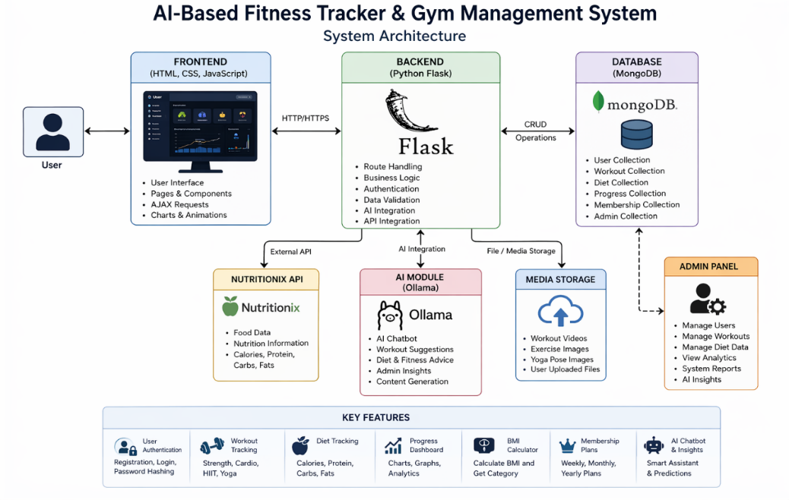
Fig 4.1: System Architecture
Table 4.1: System Architecture Description Table
Layer | Component | Description | Technology / Tool Used | Function / Responsibility
Presentation Layer (Frontend) | User Interface | Provides graphical interface for users to interact with the system. | HTML, CSS, JavaScript | Displays pages, collects user input, shows results and information.
Presentation Layer (Frontend) | Admin Interface | Provides interface for administrators to manage the system. | HTML, CSS, JavaScript | Manage users, workouts, memberships, and view analytics.
Application Layer (Backend) | Web Server | Handles client requests, routing and responses. | Python Flask | Processes requests and returns appropriate responses.
Application Layer (Backend) | Authentication Module | Manages user registration, login, logout and session handling. | Flask, Werkzeug, Bcrypt (Hashing) | Verifies users and secures access to the system.
Application Layer (Backend) | Workout Management Module | Handles workout selection, fetches workout details and displays to users. | Flask, Python Logic | Provides workout categories, levels, videos, images and details.
Application Layer (Backend) | Diet Management Module | Manages diet related queries and retrieves nutrition data. | Flask, API Handling | Searches food items and displays nutritional values.
Application Layer (Backend) | AI Module | Provides AI based chatbot, workout suggestions and admin insights. | Ollama (AI Model) | Answers user queries, gives suggestions and generates insights.
Application Layer (Backend) | API Integration Module | Connects system with external Nutrition API to fetch food and nutrition data. | Nutritionix API | Fetches food data like calories, protein, carbs, fats etc.
Data Layer (Database) | Database | Stores all system data including users, workouts, diet records, progress and memberships. | MongoDB | Performs data storage, retrieval, updates and deletion.
Data Layer (Database) | Media Storage | Stores images, videos, exercise demo files and other media. | File Storage (Local / Cloud) | Supports storage and retrieval of media files for display.

4.2 Data Flow Diagram (DFD)

The Data Flow Diagram (DFD) represents the flow of data within the system and illustrates how information is processed and transferred between different components. It provides a clear understanding of how user inputs are transformed into outputs through various processes.
At the highest level, known as the Level 0 DFD (Context Diagram), the system is represented as a single process that interacts with external entities such as Users and Administrators. Users provide inputs such as login credentials, workout selections, and diet queries, while the system responds with outputs such as authentication results, workout details, and nutritional information.
At the Level 1 DFD, the system is broken down into multiple processes, including:
- Authentication Process
- Workout Management Process
- Diet Management Process
- Progress Tracking Process
- AI Processing Module
The Authentication Process receives user credentials, verifies them against the database, and returns authentication status. If the credentials are valid, the user is granted access to the system.
The Workout Management Process handles user requests related to workouts. When a user selects a workout category and level, the system retrieves relevant data from the database and displays it on the interface.
The Diet Management Process interacts with the Nutritionix API. When a user enters a food item, the system sends a request to the API, retrieves nutritional data, and displays it in a structured format.
The Progress Tracking Process collects user activity data and stores it in the database. It then generates visual representations such as charts and graphs to display progress over time.
The AI Processing Module analyzes user data and generates recommendations and insights. It processes inputs such as user preferences and workout history to provide personalized suggestions.
Data flows between these processes and the database. For example, user data is stored in the Users collection, while workout data is stored in the Workouts collection. The system retrieves and updates this data as needed.
The DFD ensures that all data movements are clearly defined, reducing the risk of data inconsistencies and improving system efficiency.
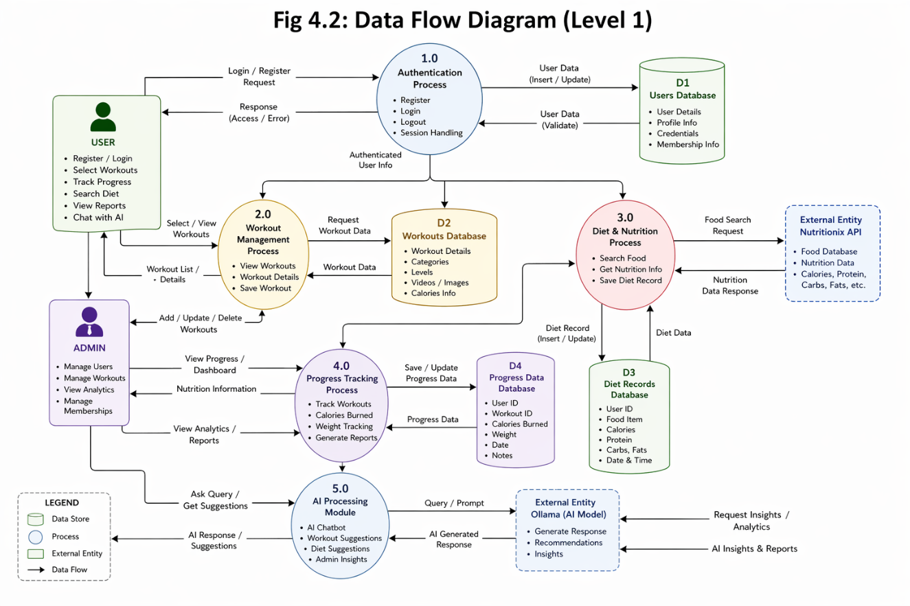
Fig 4.2: Data Flow Diagram (Level 1)

Table 4.2: Data Flow Description Table
Process No. | Process Name | Description | Input | Output | Data Store Used
1.0 | Authentication Process | Handles user registration, login, logout, and session management | User credentials | Authentication status | D1: Users Database
2.0 | Workout Management Process | Manages workout selection, viewing details, and saving workouts | Workout request | Workout details | D2: Workouts Database
3.0 | Diet & Nutrition Process | Retrieves and stores nutritional data using external API | Food search query | Nutrition information | D3: Diet Records Database
4.0 | Progress Tracking Process | Tracks user progress including workouts, calories, and weight | User activity data | Progress reports | D4: Progress Database
5.0 | AI Processing Module | Generates AI-based responses, suggestions, and insights | User queries / prompts | AI recommendations | External (Ollama AI Model)

4.3 Use Case Diagram

The Use Case Diagram illustrates the interactions between different actors and the system. It provides a high-level view of system functionality and helps in understanding user requirements.
The system has two primary actors:
- User
- Administrator
The User interacts with the system to perform various activities. These include registering for an account, logging in, selecting workouts, tracking progress, viewing diet information, and using the AI chatbot.
The Administrator has additional privileges and is responsible for managing the system. This includes managing user accounts, updating workout data, monitoring system performance, and analyzing user activity.
The main use cases for the user include:
- Register Account
- Login
- View Workouts
- Select Workout Level
- Track Progress
- View Diet Information
- Calculate BMI
- Subscribe to Membership
- Use AI Chatbot
The main use cases for the administrator include:
- Manage Users
- Manage Workouts
- View Analytics
- Monitor System Activity
Each use case represents a specific interaction between the actor and the system. The relationships between use cases are defined using associations, include, and extend relationships.
For example, the “Login” use case is required before accessing other features, making it a prerequisite for most interactions. Similarly, the “View Workouts” use case may include “Select Workout Level” as a sub-function.
The Use Case Diagram helps in identifying system functionalities and ensures that all user requirements are addressed during development.
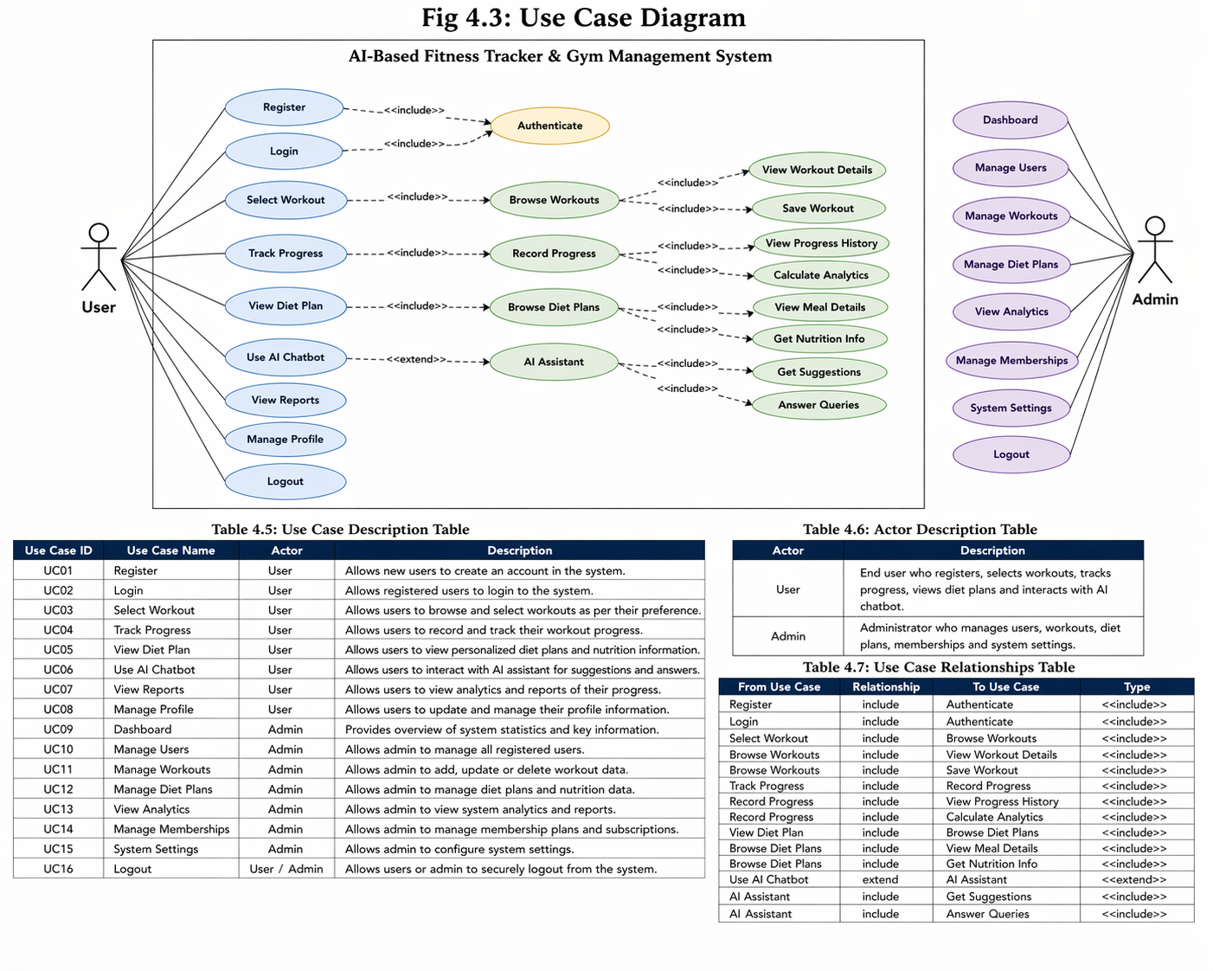
Fig 4.3: Use Case Diagram

Table 4.3: Use Case Description Table
Use Case ID | Use Case Name | Actor | Description
UC01 | Register | User | Allows new users to create an account in the system.
UC02 | Login | User | Allows registered users to login to the system.
UC03 | Select Workout | User | Allows users to browse and select workouts as per their preference.
UC04 | Track Progress | User | Allows users to record and track their workout progress.
UC05 | View Diet Plan | User | Allows users to view personalized diet plans and nutrition information.
UC06 | Use AI Chatbot | User | Allows users to interact with AI assistant for suggestions and answers.
UC07 | View Reports | User | Allows users to view analytics and reports of their progress.
UC08 | Manage Profile | User | Allows users to update and manage their profile information.
UC09 | Dashboard | Admin | Provides overview of system statistics and key information.
UC10 | Manage Users | Admin | Allows admin to manage all registered users.
UC11 | Manage Workouts | Admin | Allows admin to add, update or delete workout data.
UC12 | Manage Diet Plans | Admin | Allows admin to manage diet plans and nutrition data.
UC13 | View Analytics | Admin | Allows admin to view system analytics and reports.
UC14 | Manage Memberships | Admin | Allows admin to manage membership plans and subscriptions.
UC15 | System Settings | Admin | Allows admin to configure system settings.
UC16 | Logout | User / Admin | Allows users or admin to securely logout from the system.

4.4 Entity Relationship Diagram (ER Diagram)

The Entity Relationship Diagram (ER Diagram) represents the structure of the database and defines the relationships between different entities in the system. It is a crucial component of system design, as it ensures efficient data organization and retrieval.
The main entities in the system include:
- Users
- Admin
- Workouts
- Memberships
- Diet Records
- Progress Data
The Users entity contains attributes such as user ID, name, email, password, age, weight, height, and fitness level. This entity stores all information related to system users.
The Admin entity contains attributes such as admin ID, username, and password. Administrators have special privileges to manage the system.
The Workouts entity includes attributes such as workout ID, name, category (Strength, Cardio, HIIT, Yoga), level (Beginner, Intermediate, Advanced), description, sets, repetitions, duration, and calories burned.
The Memberships entity stores information about subscription plans. Attributes include membership ID, plan type, price, duration, and user ID. This entity is linked to the Users entity through a one-to-many relationship, as one user can have one active membership at a time.
The Diet Records entity stores information about user food intake. Attributes include record ID, user ID, food item, calories, protein, carbohydrates, and fats. This entity is linked to the Users entity.
The Progress Data entity stores user activity data such as workouts completed, calories burned, and weight changes. It is also linked to the Users entity.
Relationships between entities are defined as follows:
- A user can have multiple diet records
- A user can have multiple progress records
- A user is associated with one membership
- Workouts are accessed by users but stored independently
These relationships ensure that data is organized efficiently and can be retrieved easily when needed.

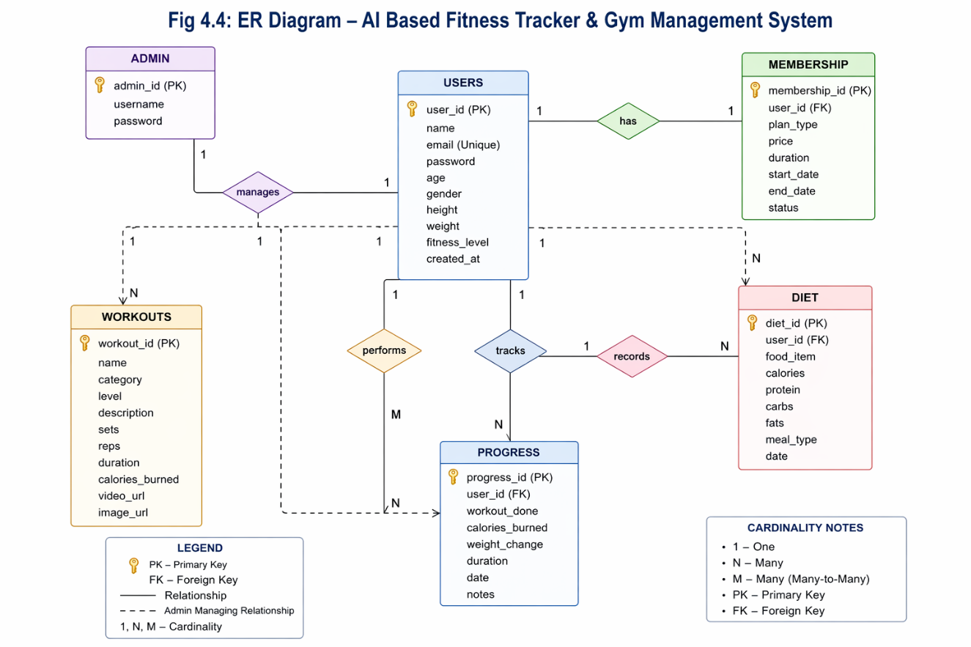
Fig 4.4: ER Diagram – AI Based Fitness Tracker & Gym Management System

Table 4.4: E R diagram
Entity Name | Attributes | Primary Key | Foreign Key | Description
USERS | User_id, name, email, password, age, gender, height, weight, fitness_level, created_at | user_id | — | Stores all user personal and fitness-related information.
ADMIN | Admin id, username, password | admin_id | — | Stores administrator login credentials and system control details.
WORKOUTS | workout_id, name, category, level, description, sets, reps, duration, calories_burned, video_url, image_url | workout_id | — | Contains all workout details including exercises and media.
MEMBERSHIP | membership_id, user_id, plan_type, price, duration, start_date, end_date, status | membership_id | user_id | Stores membership subscription details of users.
DIET | diet_id, user_id, food_item, calories, protein, carbs, fats, meal_type, date | diet_id | user_id | Stores user diet and nutrition intake records.
PROGRESS | progress_id, user_id, workout_done, calories_burned, weight_change, duration, date, notes | progress_id | user_id | Tracks user fitness progress and workout history.

CHAPTER 5
IMPLEMENTATION
5.1 Frontend Implementation
The frontend implementation focuses not only on design but also on enhancing usability, accessibility, and real-time interaction. The system follows a component-based UI structure, where each page is divided into reusable sections such as navigation bar, content area, and footer. This modular approach improves maintainability and consistency across the application.
The navigation system is designed to provide smooth transitions between pages without reloading, enhancing user experience. JavaScript is used to dynamically update content based on user actions. For example, when a user selects a workout category, the content is updated instantly to display relevant exercises.
Form handling is an important part of the frontend. Registration and login forms include validation rules such as email format checking, password strength validation, and required field verification. Error messages are displayed in real time, guiding users to correct their inputs.
The dashboard is designed as a dynamic interface that displays user-specific data. Charts and graphs are integrated to show progress such as calories burned, workouts completed, and weight changes. These visual elements are implemented using JavaScript-based charting techniques, which enhance understanding and engagement.
Animations play a significant role in improving the user interface. Smooth transitions, hover effects, and loading animations are used to create a modern and interactive experience. These features make the application more attractive and user-friendly.
The workout interface is designed to provide detailed guidance. Each exercise includes step-by-step instructions, visual media, and structured information. The layout ensures that users can easily follow the workout without confusion.
The diet module interface includes search functionality with instant suggestions. As users type a food item, suggestions can be displayed dynamically, improving usability. The results are presented in both textual and graphical formats.
Overall, the frontend implementation emphasizes interactivity, responsiveness, and user engagement, making the system intuitive and easy to use.
5.2 Backend Implementation
The backend implementation is designed using a modular and layered approach, ensuring scalability and maintainability. Each functionality is divided into separate modules, allowing independent development and testing.
The request-response cycle begins when the frontend sends a request to the server. The Flask server receives this request, processes it using defined routes, and interacts with the database or external services as required. The processed data is then returned to the frontend in a structured format.
The authentication system is implemented with strong security measures. Passwords are hashed using secure algorithms, ensuring that sensitive information is not stored in plain text. Session management ensures that users remain authenticated during their interaction with the system, while unauthorized access is restricted.
The backend uses RESTful principles to manage communication between the client and server. Each operation such as fetching workouts, updating user data, or retrieving diet information is handled through specific endpoints. This structured approach improves clarity and efficiency.
Database operations are performed using MongoDB collections. The system uses efficient querying techniques to retrieve data quickly. Indexing can be applied to frequently accessed fields such as user ID and email to improve performance.
The workout management module includes logic for filtering workouts based on category and difficulty level. This ensures that users receive relevant results without unnecessary data overload.
The progress tracking module calculates metrics dynamically. For example, when a user completes a workout, the system updates total calories burned and records the activity. These updates are reflected in the dashboard in real time.
Error handling is implemented using exception handling mechanisms. If an error occurs, the system returns meaningful messages instead of crashing. This improves reliability and user experience.
The backend is designed to be scalable. Additional features can be integrated without affecting existing functionality, making the system future-ready.
5.3 AI Model and System Integration
The AI integration is the most advanced component of the system and significantly enhances its functionality. The use of Ollama enables the system to process natural language inputs and generate intelligent responses.
The AI chatbot operates using a prompt-response mechanism. When a user submits a query, the backend forwards the input to the AI model. The model processes the query using natural language understanding and generates a response, which is then sent back to the user. This interaction simulates a real-time conversation.
The chatbot can handle various types of queries, including workout suggestions, diet advice, and general fitness guidance. For example, a user can ask for a beginner workout plan, and the system will generate a suitable response based on predefined logic and AI processing.
The recommendation system uses user data to provide personalized suggestions. It considers factors such as fitness level, workout history, and user preferences. Based on this data, the AI generates customized workout plans, ensuring better results and user satisfaction.
The AI module also supports context-aware responses. This means that it can maintain context during a conversation, providing more relevant and meaningful answers.
For administrators, the AI module performs data analysis. It processes large volumes of user data to identify patterns and trends. For example, it can determine which workouts are most popular or which users are most active. These insights help administrators optimize system performance and improve user engagement.
The integration of the Nutritionix API complements the AI functionality. The API provides accurate nutritional data, which is processed and presented to users. The system can combine this data with AI recommendations to provide holistic fitness guidance.
The interaction between AI, backend, and database is carefully managed to ensure efficiency. Requests are processed asynchronously where possible, reducing response time and improving performance.
Security considerations are also taken into account. Sensitive data is not directly exposed to the AI model, ensuring user privacy.
Overall, the AI integration transforms the system into an intelligent platform capable of delivering personalized, interactive, and data-driven experiences.
5.4 System Workflow
The system workflow describes the step-by-step operation of the application from user interaction to data processing and output generation.
The process begins when a user accesses the application through a web browser. The user registers or logs into the system using valid credentials. Once authenticated, the user is redirected to the dashboard.
From the dashboard, the user can select various modules such as workouts, diet tracking, or progress monitoring. When a workout is selected, the system retrieves relevant data from the database and displays it along with media content.
If the user interacts with the AI chatbot, the query is sent to the backend and processed by the AI model. The response is then displayed on the interface.
For diet tracking, the user enters a food item, and the system sends a request to the Nutritionix API. The retrieved data is processed and displayed in a structured format.
All user activities are recorded in the database. The progress tracking module updates user statistics and generates visual reports.
Administrators can log in to access the admin panel, where they can manage users, update data, and view analytics.
The workflow ensures smooth interaction between different components, providing a seamless user experience.

CHAPTER 6
TESTING
6.1 Testing Strategy
Testing plays a crucial role in ensuring the quality, reliability, and performance of the developed system. In the “AI-Based Fitness Tracker & Gym Management System,” a comprehensive and structured testing strategy is adopted to validate all system components and ensure that they function according to the specified requirements.
The testing process follows a multi-level testing approach, which includes unit testing, integration testing, and system testing. Each level is designed to identify and eliminate errors at different stages of development. This layered testing approach ensures that issues are detected early and resolved effectively, reducing the risk of system failure after deployment.
The strategy begins with requirement-based testing, where all functionalities defined in the system requirements specification are verified. Each feature, such as authentication, workout tracking, diet management, and AI integration, is tested against its expected behavior.
Another important aspect of the testing strategy is risk-based testing. Critical modules such as authentication, database operations, and AI interactions are given higher priority during testing. This ensures that the most important functionalities are thoroughly validated.
The system also follows a black-box testing approach, where the internal code structure is not considered, and the focus is on input-output validation. This approach is particularly useful for testing user-facing features such as login, workout selection, and chatbot interaction.
In addition, white-box testing techniques are applied at the development level to verify internal logic, code structure, and execution paths. This ensures that the backend logic is efficient and free from logical errors.
The testing strategy also includes regression testing, which ensures that newly added features do not affect existing functionalities. Whenever updates or modifications are made, previously tested modules are re-tested to confirm stability.
Performance testing is conducted to evaluate system responsiveness and scalability. The system is tested under different load conditions to ensure that it can handle multiple users simultaneously without significant delays.
Security testing is a critical component of the strategy. The system is tested for vulnerabilities such as unauthorized access, data leakage, and session hijacking. Techniques such as password encryption, secure session handling, and input validation are verified during this phase.
The testing process also includes user acceptance testing (UAT), where the system is evaluated from the end-user perspective. This ensures that the application meets user expectations and provides a satisfactory experience.
Overall, the testing strategy is designed to ensure that the system is robust, secure, and capable of delivering a seamless user experience.
Table 6.1: Testing Strategy Summary
Testing Type | Description | Purpose
Requirement-Based Testing | Testing based on system requirements | Ensures all features work as specified
Risk-Based Testing | Focus on critical modules like authentication and AI | Reduces chances of major system failure
Black-Box Testing | Tests functionality without code knowledge | Validates input-output behavior
White-Box Testing | Tests internal code logic and flow | Ensures efficient backend logic
Regression Testing | Re-testing after updates | Ensures no new bugs are introduced
Performance Testing | Testing under load conditions | Ensures system stability
Security Testing | Testing for vulnerabilities | Protects user data
User Acceptance Testing | Testing from user perspective | Ensures user satisfaction
6.2 Unit Testing
Unit testing is the first level of testing, where individual components or modules of the system are tested independently. The primary objective of unit testing is to verify that each module performs its intended function correctly.
In this system, unit testing is applied to various modules such as authentication, workout management, diet processing, AI interaction, and database operations. Each function within these modules is tested with multiple input scenarios to ensure correctness.
The authentication module is tested extensively, as it is a critical component of the system. Test cases include verifying login functionality with valid credentials, handling incorrect passwords, checking email validation, and ensuring proper session management. Password hashing mechanisms are also tested to confirm that sensitive data is securely stored.
The workout management module is tested to ensure that it retrieves accurate data from the database and displays it correctly on the frontend. Different categories and levels are tested to verify that filtering logic works as expected.
The diet management module is tested by providing various food inputs and verifying the response from the Nutritionix API. The system is tested for both valid and invalid inputs to ensure proper error handling.
The AI module undergoes unit testing to verify that it generates relevant responses based on user queries. Different types of queries are tested to evaluate the accuracy and consistency of AI-generated outputs.
The progress tracking module is tested to ensure that user activity is recorded correctly and calculations such as calories burned and weight changes are accurate.
Unit testing helps in identifying errors at an early stage, making it easier to fix issues before they affect other parts of the system. It also improves code quality and ensures that each component functions independently without errors.
Table 6.2: Unit Testing Module Coverage
Module | Test Focus Area | Description
Authentication Module | Login, Registration | Validates user credentials and session handling
Workout Module | Data retrieval, filtering | Ensures correct workouts are displayed
Diet Module | API response handling | Validates nutrition data fetching
AI Module | Response accuracy | Checks relevance of chatbot responses
Progress Module | Data recording | Ensures correct tracking of user activities

6.3 Integration Testing
Integration testing focuses on verifying the interaction between different modules of the system. While unit testing ensures that individual components work correctly, integration testing ensures that these components function properly when combined.
In the “AI-Based Fitness Tracker & Gym Management System,” integration testing is essential due to the involvement of multiple interconnected modules such as frontend, backend, database, AI module, and external APIs.
One of the key integration scenarios is the interaction between the frontend and backend. When a user performs an action, such as logging in or selecting a workout, the frontend sends a request to the backend. The backend processes this request and returns the appropriate response. This communication is tested to ensure accuracy and reliability.
Another important integration is between the backend and MongoDB database. The system performs various database operations such as storing user data, retrieving workout details, and updating progress records. Integration testing ensures that these operations are executed correctly and data consistency is maintained.
The integration with the Nutritionix API is also tested thoroughly. The system sends requests to the API and receives nutritional data, which is then processed and displayed. The testing ensures that API responses are handled correctly and errors are managed effectively.
The AI module integration is tested to verify that user queries are correctly processed and appropriate responses are generated. The communication between the backend and the AI model is validated to ensure smooth interaction.
Integration testing also includes testing data flow between modules. For example, when a user completes a workout, the data must be updated in the database and reflected in the progress dashboard. This entire flow is tested to ensure consistency.
Overall, integration testing ensures that all system components work together seamlessly, providing a smooth and reliable user experience.
Table 6.3: Integration Flow Table
Integration | Components Involved | Description
User Request Flow | Frontend → Backend | Sends user request for processing
Data Storage Flow | Backend → Database | Stores and retrieves data
API Integration Flow | Backend → Nutritionix API | Fetches nutrition data
AI Interaction Flow | Backend → Ollama AI | Processes user queries
Response Flow | Backend → Frontend | Sends processed output to UI

6.4 System Testing
System testing is the final stage of testing, where the complete system is evaluated as a whole. The objective is to ensure that the system meets all functional and non-functional requirements and operates correctly in real-world scenarios.
In this phase, the entire application is tested from the user’s perspective. All features, including authentication, workout tracking, diet management, AI chatbot, and admin functionalities, are tested in an integrated environment.
The system is tested under various conditions to evaluate its performance and reliability. This includes testing with multiple users accessing the system simultaneously, handling large amounts of data, and processing multiple requests at the same time.
Usability testing is conducted to ensure that the user interface is intuitive and easy to navigate. The design, layout, and responsiveness of the application are evaluated to provide a smooth user experience.
Performance testing is carried out to measure system response time, load handling capacity, and overall efficiency. The system is tested under different load conditions to ensure that it remains stable and responsive.
Security testing is performed to identify potential vulnerabilities and ensure data protection. This includes testing for unauthorized access, validating input fields, and ensuring secure data transmission.
Compatibility testing ensures that the system works correctly across different devices and browsers. The application is tested on desktops, laptops, tablets, and mobile devices to ensure consistent performance.
Error handling testing is also conducted to verify that the system can handle unexpected situations gracefully. Proper error messages are displayed, and the system continues to function without crashing.
System testing confirms that all modules work together as expected and that the system is ready for deployment.

Table 6.4: System Testing Coverage
Testing Area | Description | Purpose
Functional Testing | Tests all features like login, workout, diet | Ensures system works correctly
Usability Testing | Evaluates UI and user experience | Improves ease of use
Performance Testing | Tests system under load | Ensures fast response
Security Testing | Checks data protection | Prevents unauthorized access
Compatibility Testing | Tests on different devices | Ensures cross-platform support
Error Handling Testing | Tests system behavior on errors | Prevents crashes

CHAPTER 7
SCREEN SHOTS
7.1 Application Scree Shots
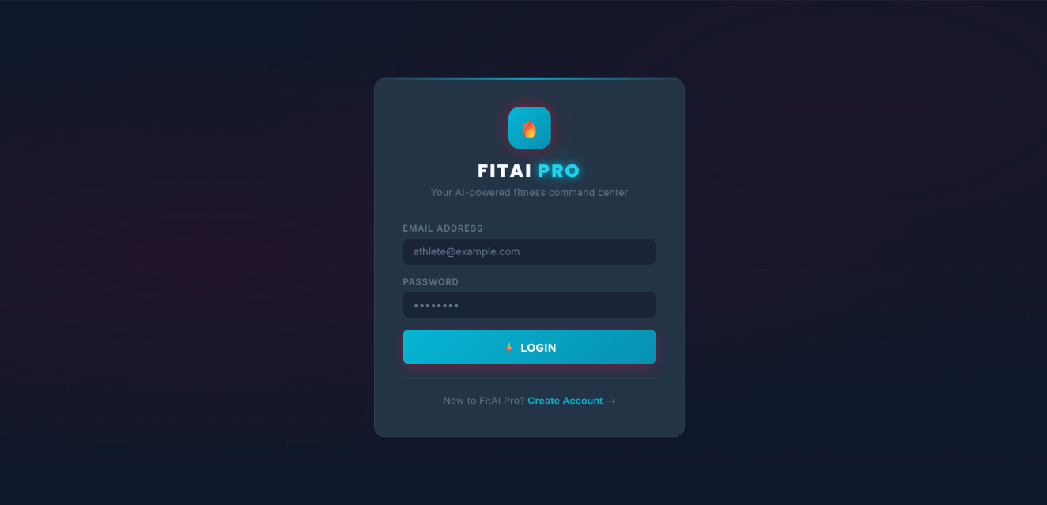
Fig 7.1: Login Page
The login page is the entry point of the system where registered users can access their accounts. It consists of input fields for email and password, along with a login button. The system validates user credentials and grants access only if the entered details are correct. Error messages are displayed for invalid inputs, ensuring secure authentication.
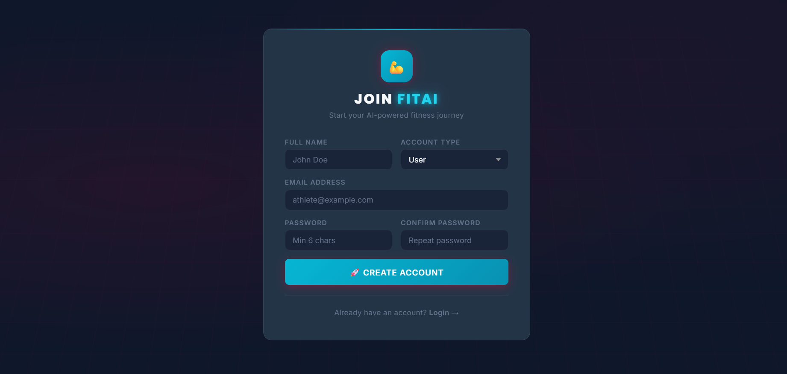
Fig 7.2: Registration Page
The registration page allows new users to create an account in the system. It includes fields such as name, email, password, and other personal details. Proper validation is applied to ensure that all required fields are filled correctly. Once registered, the user can log in and access system features.
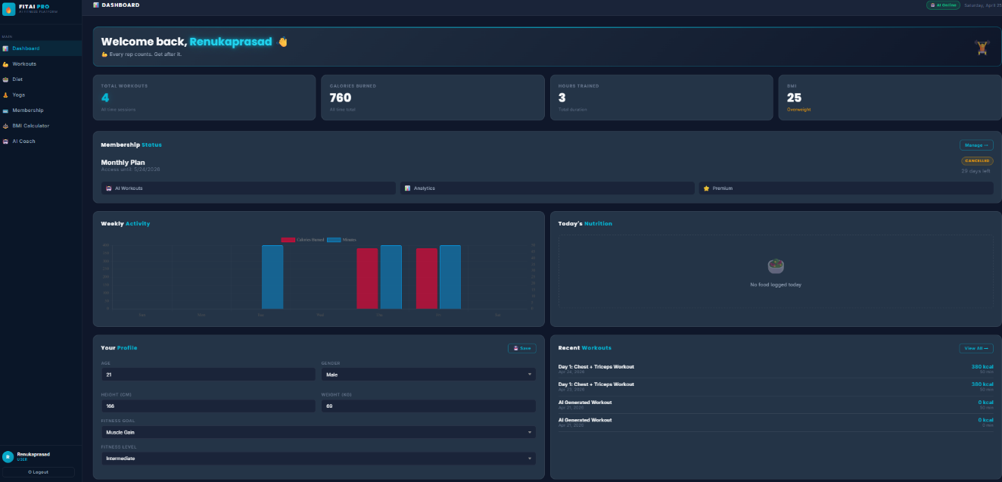
Fig 7.3: User Dashboard
The dashboard provides an overview of user activity, including workouts, calories burned, and progress statistics. It serves as the central interface where users can navigate to different modules such as workouts, diet tracking, and progress monitoring. The dashboard is designed to be interactive and user-friendly.
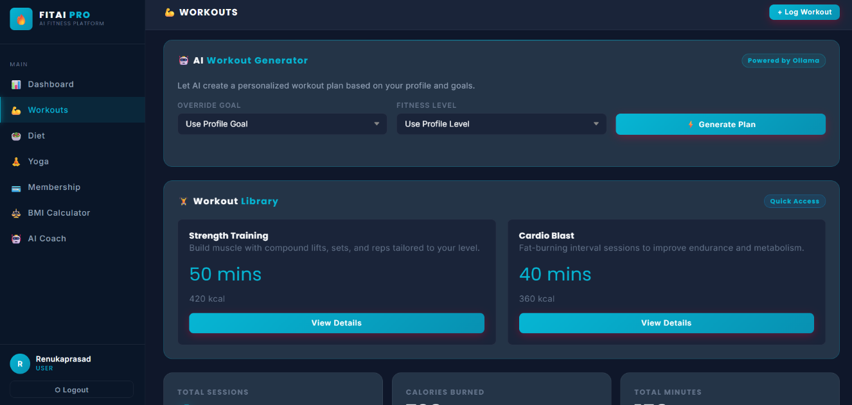
Fig 7.4: Workout Selection Page
This page displays different workout categories such as Strength, Cardio, HIIT, and Yoga. Users can select workouts based on their preferences and fitness level. The interface is designed to make navigation simple and efficient.
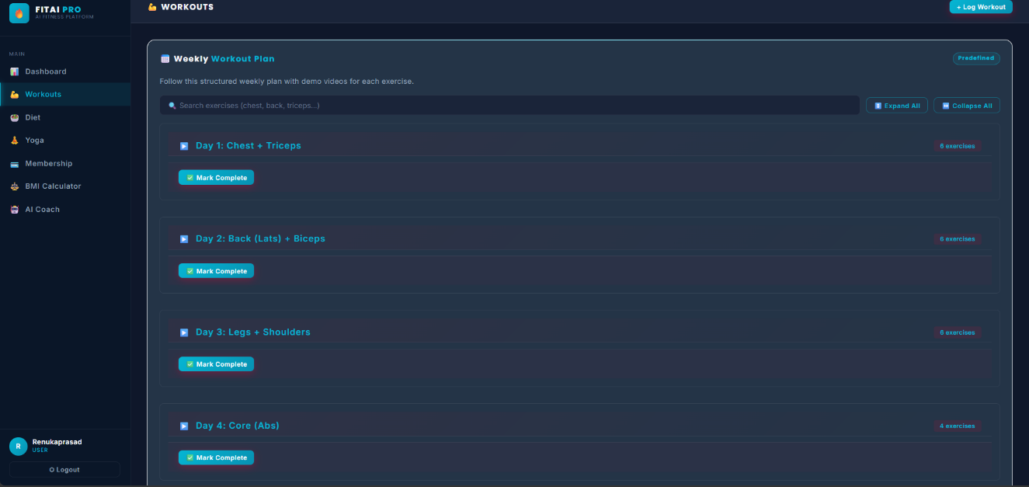
Fig 7.5: Workout Detail Page
The workout detail page provides complete information about a selected exercise. It includes description, sets, repetitions, duration, and calories burned. Demo videos and images are also provided to guide users in performing exercises correctly.
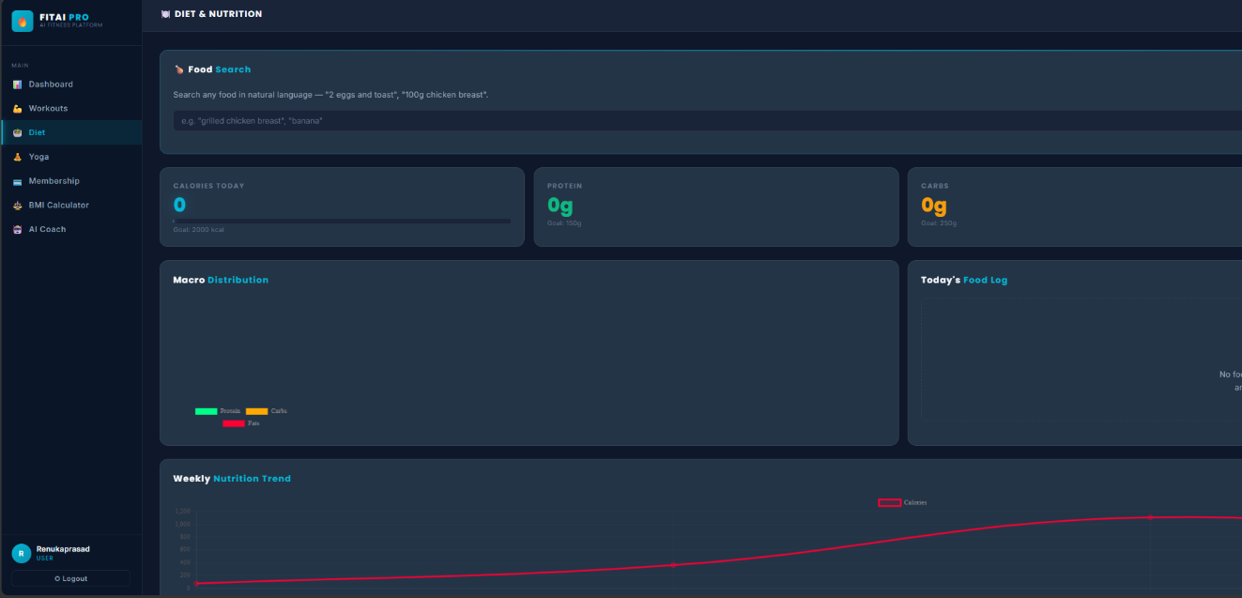
Fig 7.6: Diet and Nutrition Page
This page allows users to search for food items and view their nutritional values. The system retrieves data such as calories, protein, carbohydrates, and fats using the API. The information is displayed in a structured format for easy understanding.
Fig 7.7: Progress Tracking Page
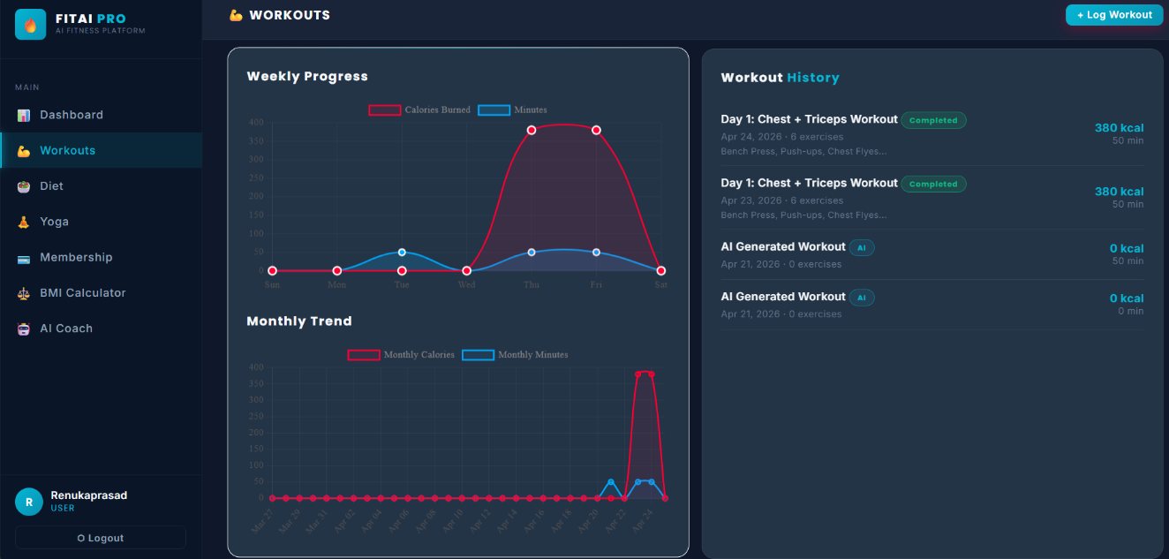
Fig 7.7: Progress Tracking Page
The progress tracking page displays user performance over time. It includes graphical representations of calories burned, workouts completed, and weight changes. This helps users monitor their fitness journey effectively.
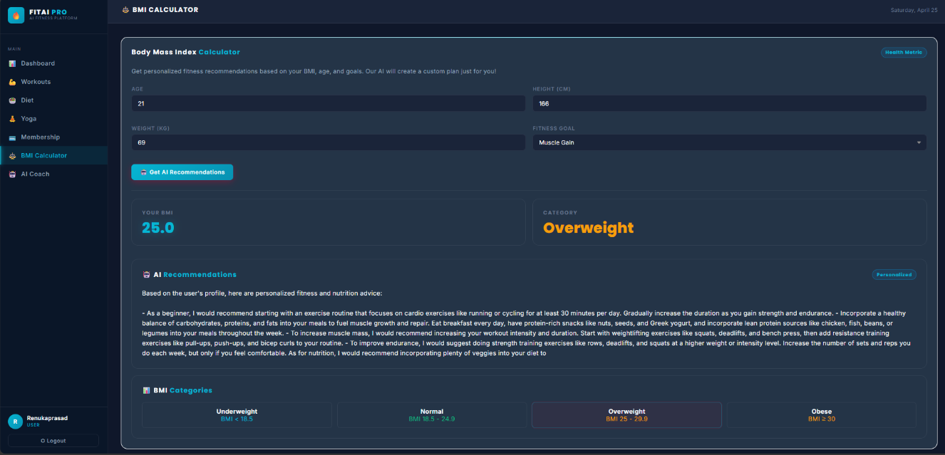
Fig 7.8: BMI Calculator

The BMI calculator allows users to calculate their Body Mass Index based on height and weight. The system classifies the result into categories such as underweight, normal, overweight, and obese, helping users understand their fitness level
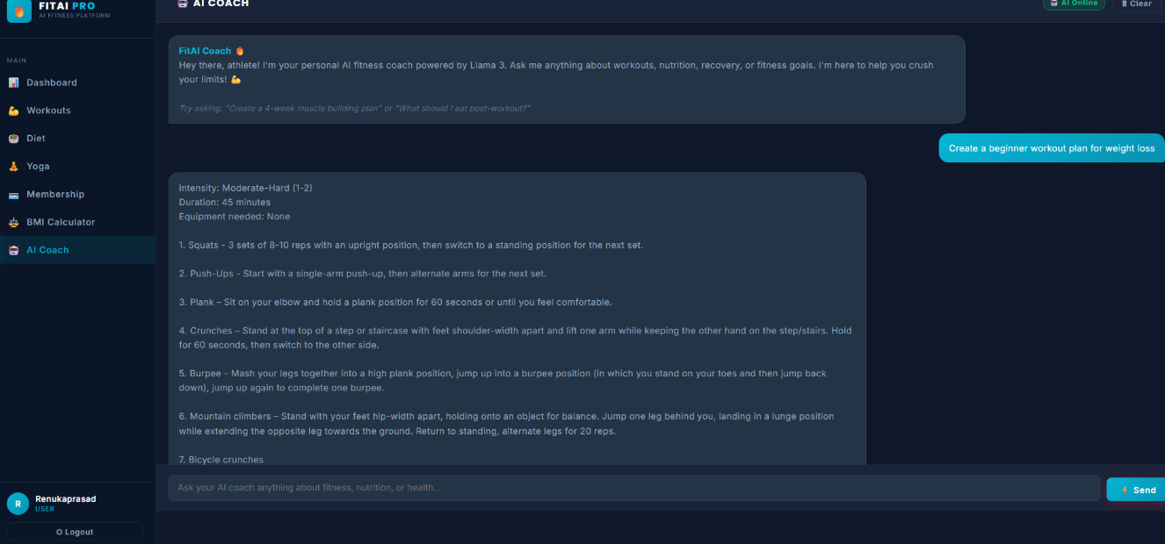
Fig 7.9: AI Chatbot
The AI chatbot interface enables users to interact with the system using natural language. Users can ask questions related to workouts, diet, and fitness. The chatbot provides intelligent responses using AI integration, improving user engagement.
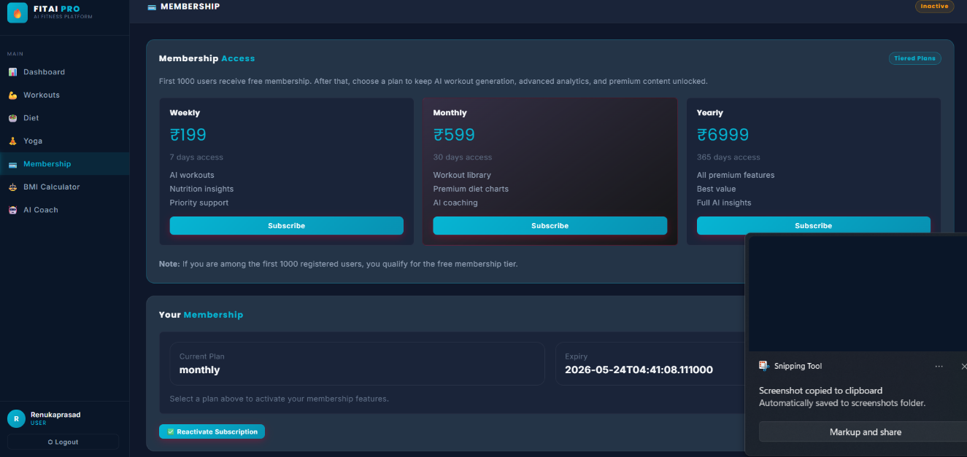
Fig 7.10: Membership Plans
This page displays different membership plans such as weekly, monthly, and yearly subscriptions. Users can select a plan based on their requirements. Special offers such as free access for initial users are also highlighted.

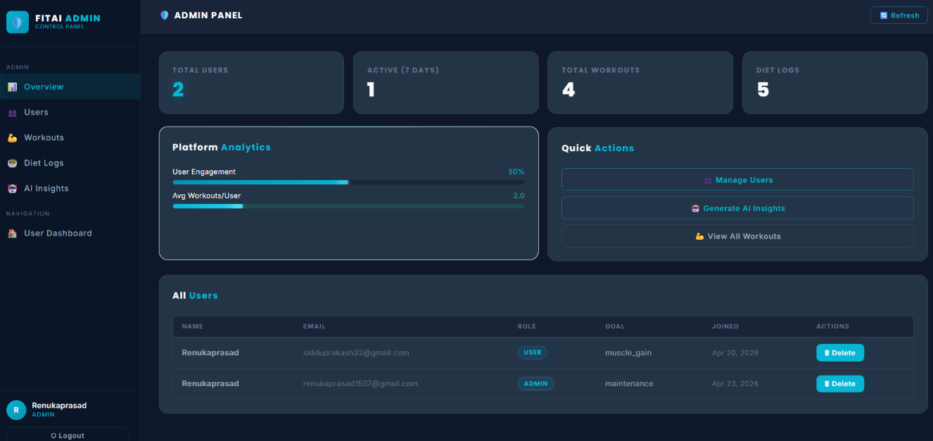
Fig 7.11: Admin Dashboard
The admin dashboard provides an overview of system data and statistics. It allows administrators to monitor system performance and user activity.

CHAPTER 8
RESULTS
8.1 Results
The “AI-Based Fitness Tracker & Gym Management System” was successfully developed and implemented as a full-stack web application. The system integrates multiple modules including authentication, workout tracking, diet management, AI assistance, and admin control, all functioning together to provide a comprehensive fitness management solution.
The authentication module performed efficiently by allowing users to securely register and log into the system. Password hashing and session management ensured that user data remained protected. The system successfully prevented unauthorized access and maintained user session integrity throughout usage.
The workout module effectively displayed categorized workouts such as Strength, Cardio, HIIT, and Yoga. Users were able to select workouts based on their fitness level (Beginner, Intermediate, Advanced), and the system provided detailed information including sets, repetitions, duration, and calories burned. The inclusion of demo videos and images improved user understanding and engagement.
The diet module successfully integrated with the Nutritionix API, enabling users to search for food items and retrieve accurate nutritional information. The system displayed values such as calories, protein, carbohydrates, and fats in a structured format. Graphical representations enhanced data visualization, making it easier for users to analyze their diet.
The progress tracking module recorded user activities and generated meaningful insights. Users were able to monitor their performance through charts and graphs, which displayed metrics such as calories burned, workouts completed, and weight changes over time.
The BMI calculator functioned accurately by calculating Body Mass Index based on user input and categorizing results into standard health ranges. This feature provided users with a quick assessment of their fitness status.
The membership module successfully handled subscription plans including weekly, monthly, and yearly options. The system also supported promotional features such as free access for initial users, demonstrating flexibility in pricing management.
The admin panel functioned effectively by allowing administrators to manage users, workouts, and system data. The admin dashboard provided useful insights into system activity, enabling efficient monitoring and control.
The AI module, powered by Ollama, was successfully integrated into the system. It provided intelligent responses to user queries, generated workout suggestions, and offered insights for administrators. The chatbot improved user interaction by enabling natural language communication.
Overall, the system achieved all its intended objectives and provided a smooth, efficient, and user-friendly experience.
8.2 Performance Analysis
The performance of the system was evaluated based on various parameters such as response time, scalability, reliability, and usability.
The system demonstrated fast response times for most operations. User authentication, workout retrieval, and data display were completed within a few seconds. API calls to the Nutritionix service were processed efficiently, although response time varied slightly depending on network conditions.
The AI module performance was satisfactory, with responses generated within an acceptable time frame. While AI processing may take slightly longer than standard operations, the delay was minimal and did not affect user experience significantly.
The system showed good scalability, as it was able to handle multiple user requests simultaneously without significant performance degradation. The use of efficient backend processing and database management contributed to this capability.
In terms of reliability, the system performed consistently without crashes or major errors. Error handling mechanisms ensured that unexpected situations were managed gracefully, and users were provided with meaningful feedback.
The usability of the system was evaluated based on user interaction and interface design. The modern UI, intuitive navigation, and responsive design contributed to a positive user experience. Users were able to easily access different features and perform tasks without difficulty.
The database performance was efficient, with quick data retrieval and storage operations. MongoDB’s flexible schema allowed the system to handle diverse data types effectively.
The security performance was also satisfactory. Password hashing, session management, and input validation ensured that user data was protected and unauthorized access was prevented.
Overall, the system demonstrated strong performance across all evaluated parameters, indicating that it is suitable for real-world deployment.

CHAPTER 9
CONCLUSION AND FUTURE SCOPE
9.1 Conclusion
The “AI-Based Fitness Tracker & Gym Management System” has been successfully designed and developed as a comprehensive web-based application that integrates fitness tracking with intelligent system features. The project aimed to create a platform that not only manages gym-related activities but also enhances user experience through the integration of Artificial Intelligence.
The system effectively addresses the limitations of traditional fitness tracking methods by providing a centralized and automated solution. Users can easily register, log in, select workouts, track their progress, and monitor their diet using a single platform. The integration of multiple modules ensures that all aspects of fitness management are covered in a structured and efficient manner.
The frontend implementation provides a modern and responsive user interface, making the system visually appealing and easy to use. The backend, developed using Flask, ensures efficient handling of requests, secure data processing, and seamless communication between different components. The use of MongoDB enables flexible and efficient data storage.
One of the key achievements of this project is the successful integration of Artificial Intelligence using Ollama. The AI module enhances the system by providing personalized workout suggestions, answering user queries, and generating useful insights for administrators. This makes the system more interactive and user-centric compared to traditional applications.
The integration of the Nutritionix API further strengthens the system by providing accurate nutritional data, allowing users to maintain a balanced diet. The progress tracking module and BMI calculator provide users with valuable insights into their fitness journey.
The admin panel plays a crucial role in managing system operations, allowing administrators to control users, workouts, and data effectively. This ensures smooth functioning and maintainability of the system.
The testing phase confirmed that the system is reliable, secure, and capable of handling real-world scenarios. All modules were tested thoroughly, and the results indicate that the system meets both functional and non-functional requirements.
In conclusion, the project successfully achieves its objectives by delivering a robust, intelligent, and user-friendly fitness management system. It demonstrates the effective use of modern web technologies and AI integration to solve real-world problems.
9.2 Future Enhancements
Although the system is fully functional, there are several areas where it can be further improved and expanded to enhance its capabilities and performance.
One of the major future enhancements is the integration of real-time workout detection using computer vision. This would allow the system to automatically detect user movements through a camera and provide real-time feedback on exercise form and accuracy.
The system can also be extended to include a mobile application version, making it more accessible to users on smartphones. This would improve convenience and increase user engagement.
Another enhancement is the integration of wearable device support, such as fitness bands and smartwatches. This would enable automatic tracking of activities such as steps, heart rate, and calories burned, providing more accurate data.
The AI module can be further improved by incorporating advanced machine learning models to provide more precise and personalized recommendations. This could include predictive analysis based on user behavior and fitness goals.
The diet module can be enhanced by adding meal planning features, where users can receive customized diet plans based on their preferences and health conditions.Social features such as community interaction, leaderboards, and challenges can be added to increase user motivation and engagement. Users could compete with others and share their progress.
The system can also include multi-language support, making it accessible to a wider audience.
Security can be further enhanced by implementing two-factor authentication (2FA) and advanced encryption techniques to protect user data.
Overall, these enhancements would make the system more powerful, scalable, and user-friendly, transforming it into a complete fitness ecosystem.

REFERENCES

[1] Flask Official Documentation,
“Flask Web Framework Documentation,”
Available: https://flask.palletsprojects.com/Accessed: 2026.This documentation was used to understand the development of backend services, routing mechanisms, request handling, and session management within the web application.

[2] MongoDB Official Documentation,
“MongoDB Database Documentation,” Available: https://www.mongodb.com/docs/
Accessed: 2026.This source provided detailed information about NoSQL database structure, collections, document storage, and efficient data retrieval techniques used in the project.

[3] Nutritionix API Documentation,
“Nutritionix API Documentation,” Available: https://developer.nutritionix.com/Accessed: 2026.This API documentation was used to integrate nutrition data into the system, including calorie count, macronutrients, and food analysis features.

[4] Ollama Documentation,
“Ollama AI Documentation,” Available: https://ollama.ai/Accessed: 2026.This documentation was used to understand AI model integration, chatbot functionality, and generation of intelligent responses within the system.

[5] HTML, CSS, JavaScript Documentation,
“MDN Web Docs,” Available: https://developer.mozilla.org/Accessed: 2026.These resources were used for designing and developing the frontend interface, including layout structuring, styling, and adding interactivity.

[6] Software Engineering,
Ian Sommerville, Software Engineering, 10th Edition, Pearson Education, 2016.This book provided fundamental concepts of software development lifecycle, system design, testing methodologies, and project management principles.

[7] Artificial Intelligence,
Stuart Russell and Peter Norvig, Artificial Intelligence: A Modern Approach, 4th Edition, Pearson, 2020.This reference helped in understanding AI concepts, intelligent systems, and decision-making processes used in the project.

[8] Web Development Resources,
Various online tutorials and learning platforms such as W3Schools and freeCodeCamp. These resources were used for practical implementation of frontend and backend technologies.
[9] Health Informatics Research Papers,
Various research articles on fitness tracking systems and AI-based health monitoring.These studies provided insights into the design and implementation of modern fitness applications.

[10] Body Mass Index Guidelines,
World Health Organization (WHO), BMI Classification Standards.Used for implementing BMI calculation and classification in the system.

